GENERAL INFORMATION
For Resource Persons

Conference Schedule and Events

Asian Conference on Disaster Reduction 2026 (ACDR2026) will be held in Singapore together with the Singapore-International Disaster & Emergency Management Expo (SIDEX) as SIDEX-ACDR2026, and in conjunction with the Fire Safety Asia Conference (FiSAC) 2026.
- Asian Conference on Disaster Reduction 2026 (ACDR2026) sessions
Date: 28–30 October 2026
Venue: Peridot Room, Singapore EXPO
1 Expo Dr, Singapore 486150
https://www.singaporeexpo.com.sg/

- SJ60 Commemorative Dinner
Date: 27 October 2026
Time: 19:00–21:00 (TBC)
Venue: The residence of the Japanese Ambassador to Singapore

- Joint Opening Ceremony and SIDEX2026 Conference
Date: 28 and 30 October 2026
Venue: Hall 3, Singapore EXPO

- Gala Dinner
Date: 28 October 2026
Time: 19:00–21:00 (TBC)
Places to Visit: Grand Ballroom, Orchard Hotel

- SCDF Parade and Dinner Reception
Date: 29 October 2026
Time: 18:00–20:05
Venue: Hall 4, Singapore EXPO

- Field Trip
Date: 29 October 2026
Time: 13:00–16:15
Venue: Details will be informed later

Registration (Please register no later than 9 October)

Please access the website below to register for the conference:

Asian Conference on Disaster Reduction 2026 (ACDR2026)

https://acdr.adrc.asia/home/ACDR2026

The ACDR2026 Secretariat will assist you with your registration.

Information for Onsite Participation

Expenses to be borne by ADRC
ADRC will cover the travel and accommodation fee for the resource person attending ACDR2026 onsite according to the below-mentioned conditions:
** No other fees than below mentioned will be borne by ADRC.

Flight Ticket
A round-trip economy class ticket (the most economical route only) to Singapore will be covered by ADRC excluding any fee that occurs during your air route such as daily allowance, visa application fee, etc.

Please kindly take the flight suggested by the ADRC. Flight tickets purchased by the participant are not acceptable for reimbursement due to the ADRC regulations.

NOTE: Airport tax and any additional payment caused by rerouting or upgrading should be covered by the participants.

Accommodation
A single occupancy room (including breakfast and Wi-Fi connection) will be provided by ADRC at:
Dorsett Changi City Singapore
3 Changi Business Park Central 1, Singapore 486037
NOTE: Personal expenses such as phone calls, laundry service, minibar, and/or extension of stay are NOT covered by the Secretariat.

Daily Allowance
Daily allowance (USD30) will be provided for the days of the conference
(28–30 October), according to your attendance.

      - Meals
Lunch will be provided for all three days to resource persons who attend the conference.

VISA Application

Please inform the ACDR2026 Secretariat immediately in case you require a visa to enter Singapore. The Secretariat will send you the necessary documents to be completed. Please check your requirements in the website below:
Immigration & Checkpoints Authority (ICA), Government of Singapore
https://www.ica.gov.sg/enter-transit-depart/entering-singapore/visa_requirements

NOTE: Visa fee should be covered by the participants.

Medical and Overseas Travel Insurance
ADRC will not take responsibility for medical or travel insurance for the participants. We strongly ask all participants to have their own travel insurance.

- Reference:
A preliminary overview of the SIDEX-ACDR 2026 and FiSAC 2026 programmes are provided below:
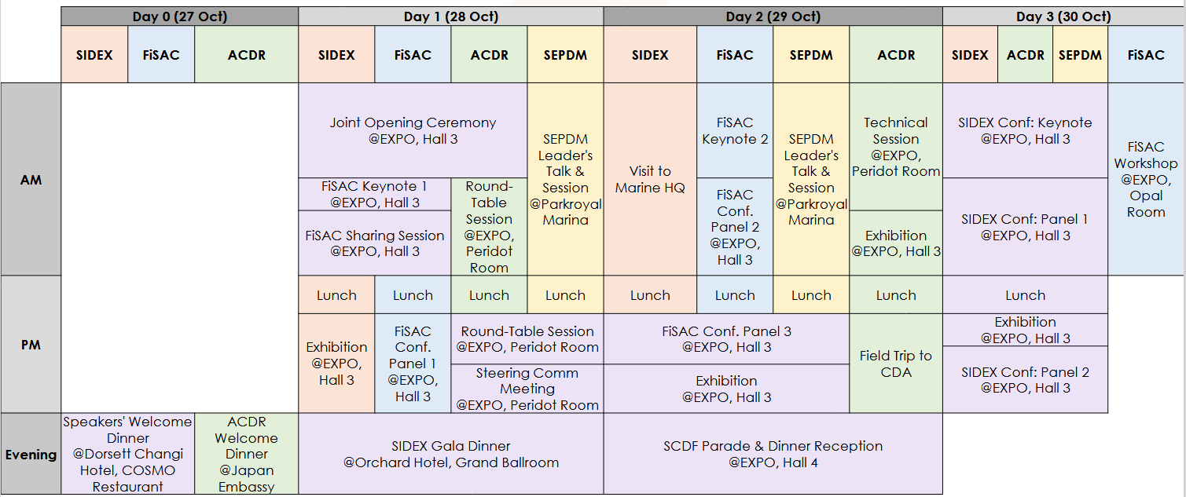

ACDR2026 Secretariat

Asian Disaster Reduction Center (ADRC)
1-5-2-5F Wakinohamakaigan-dori, Chuo-ku, Kobe 651-0073 JAPAN
TEL: +81-78-262-5540 FAX: +81-78-262-5546
E-mail: acdr2026sgp@adrc.asia
ADRC Website: https://www.adrc.asia
ACDR2026 Website: https://acdr.adrc.asia/home/ACDR2026
SIDEX-ACDR2026 Website https://sidex.sg/

